# Creating a Development VM

1. Go to Azure Portal and search for the VM image by the name “ms-training-image”

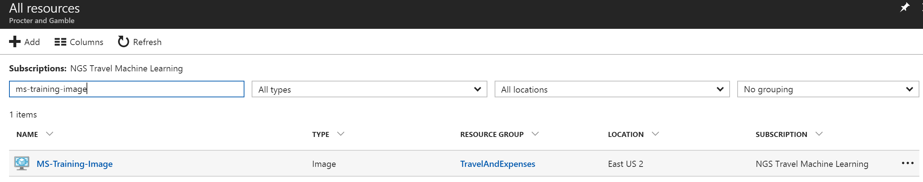

1. Select the MS-Training-Image VM and choose Create VM

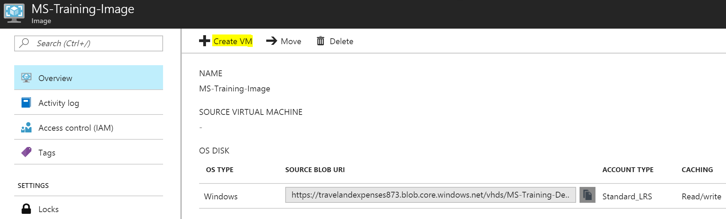

1. In the subsequent screen, enter required VM values like what is shown below.

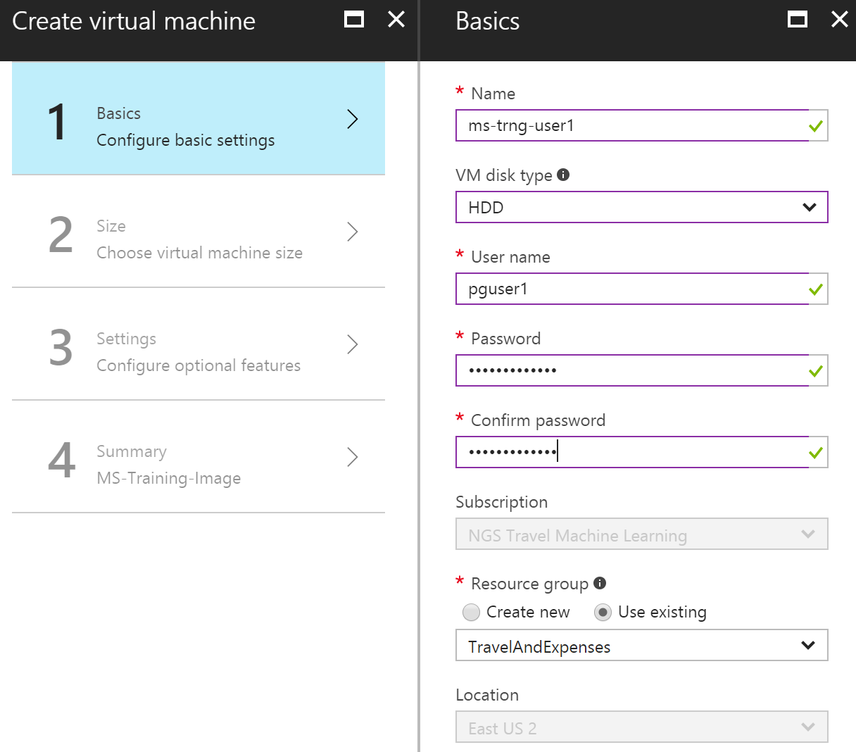

***Important: Note down the user name and password supplied here as that will be used later to login to the VM.***

1. In the next screen, choose the appropriate VM configuration as shown below.

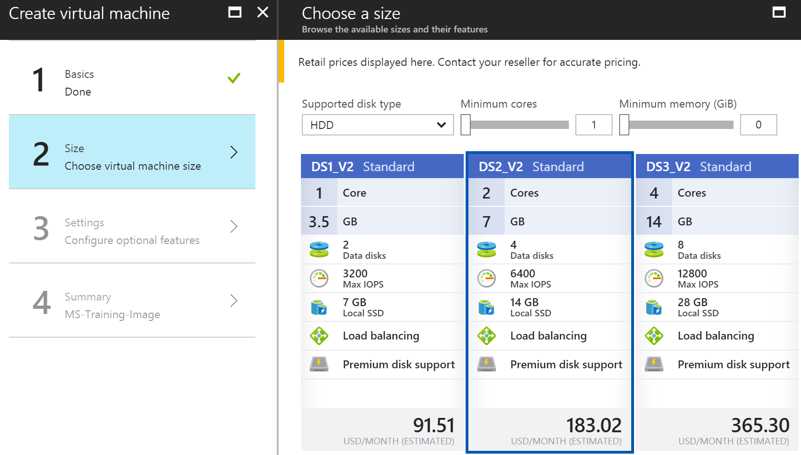

1. In the next screen, change the default network security group to “MS-Training-Dev-nsg” as shown below.

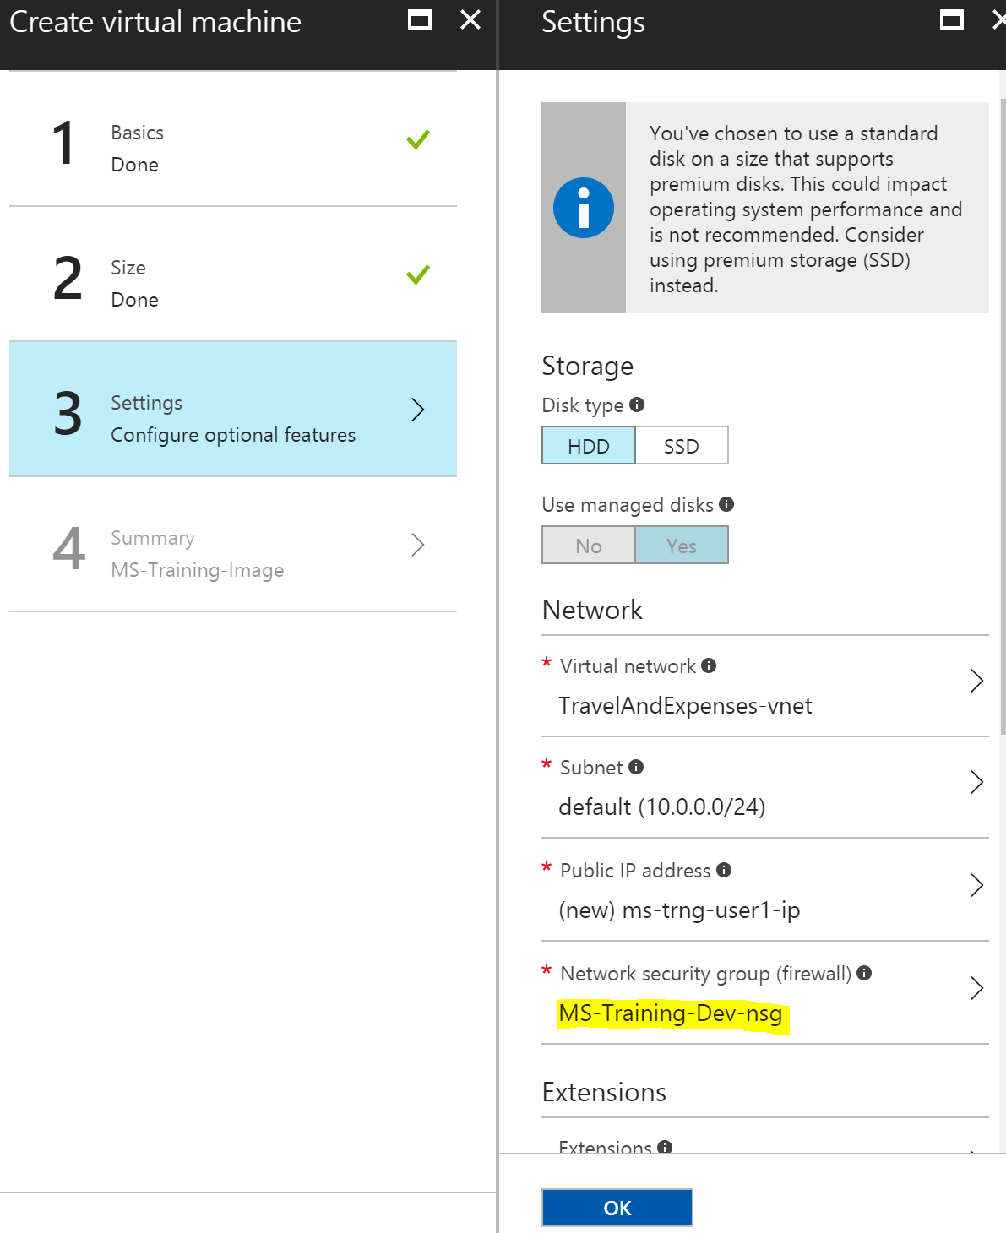

1. Click on OK in the final Summary screen to start the creation of the VM.